



NEVER FORGET A PASSWORD AGAIN

**Candidate name : Sneha Anand**

**Candidate SFID : Stepin104339**

**Report – Rem-WORD**

Course Code: <CODE>

**TABLE OF CONTENTS**

|  |  |  |
| --- | --- | --- |
| **Sl.no** | **Contents** | **Page no.** |
| **1** | **Introduction: problem statement and description.** | **2** |
| **2** | **Aim and objective** | **3** |
| **3.** | **Requirements** | **4** |
| **4.** | **Design** | **5** |
| **5.** | **Test plans and test cases** | **10** |
| **6.** | **Expected results/outcomes** | **12** |
| **7.** | **Conclusion** | **13** |
| **8.** | **References** | **14** |

**1.INTRODUCTION**

**Problem statement :**

A study found evidence that human memory naturally tends to erase information temporarily if it is not been revised frequently . It's well-known that text-based passwords are hard to remember . Less frequently used passwords are likely to be forgotten. Also , many people struggle with passwords because you need a lot of them nowadays for different accounts being created across websites or web applications like Facebook, Gmail or even any banking websites. Though there is a provision to create a new password , the process at times can be time consuming . Hence, a system which enables the user to store the passwords corresponding to certain emails used for a particular website or app can be a solution to such problems.

**Description:**

This password archive system is a simple console application built without graphics. In this project, users can add new data, display existing data and search data used for a particular website or an app. This project is basically manually updating the email - password archive into personal device or console based application so that the users can know the details used for their account in a particular website or an app.

**2.AIM AND OBJECTIVE**

**AIM OF THE APPLICATION :**

* Maintaining the website or app details used by the user.
* Users can easily search and retrieve the data with in less time
* Users can view the data used for particular application or website as and when required.
* User can access a remote file which acts as an archive of all the website related emails and passwords.

**OBJECTIVE :**

This application will help the user intending to store and retrieve the accounts details used across various websites or web applications.

The objectives of this console based application are :

* To create a user friendly environment .
* Provide access to saved data .
* Provide different functionalities like add , search , view all etc. that the user can use when required.
* To provide only authorized access to the data .

**3. REQUIREMENTS**

**PROJECT TECHINCAL SPECIFICATION :**

* Editor : CODEBLOCKS VERISON 20.3
* Compiler : GNU GCC compiler
* Programming language : C
* Project type : EMAIL-PASSWORD ARCHIVE

**SYSTEM REQUIREMENTS:**

* Operating system : Windows XP, Vista, 7, 8, or 10
* Memory : 256 MB
* Processor : Latest
* Windows installer : latest version as per OS

Requirements

**4. DESIGN**

Rem-WORD is a console-based application which is able to store details ( emails and passwords) used for any websites or apps.

The important modules that are going to implement in the proposed system.

* Login
* Adding new data
* Search for existing data
* View all data.

The present program will make use of the following :

* Pre-processor commands.
* Functions
* Variables
* Statements
* Expressions.

**Architectural Description/Design**

* Name: Rem-WORD login Page

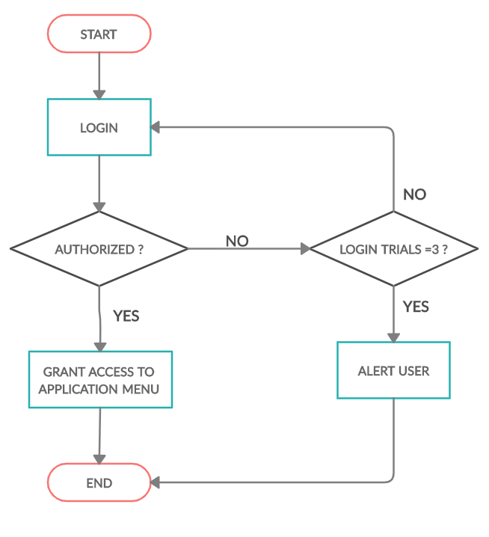

**Description:**

First page contains the welcome message as well as the login to direct the user to menu page. First page consists of LOGIN which prompts the user to enter the user id and password to enter the Rem-WORD .

* Name: MENU for application

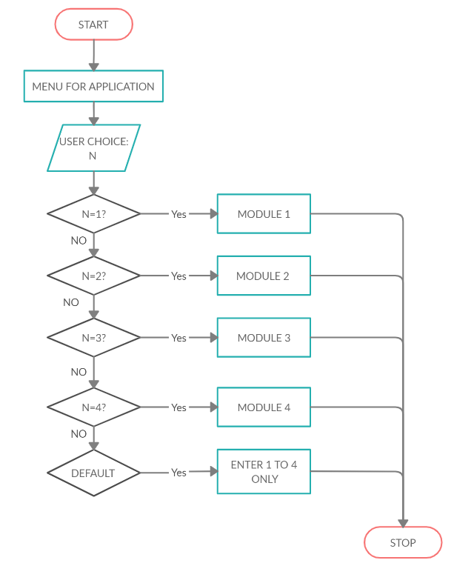

**DESCRIPTION:**

The menu lists out the various options which the user can select. The menu consists of the following options :

1. **Add new data** – allows user to add new data related to a website/an app.
2. **Search data** – allows the user to search data related to a website/ an app.
3. **View all data**- allows user to view data related to all the websites / apps.
4. **Exit console**

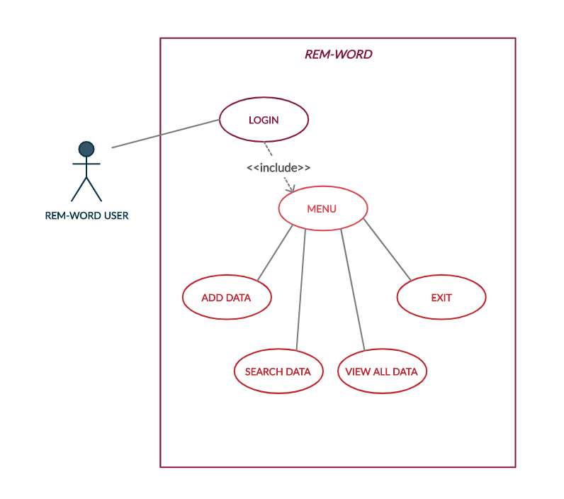

**DESCRIPTION OF EACH OPTION**

1. ADD NEW DATA : The add new data option will take in the user input i.e. website/app name , email and password used for the said website or app . This data will be stored in a separate file .
2. SEARCH DATA : The search data option will allow the user to type in the name of the website or app details of which he/she wants to view . This option will show all the emails and passwords used for the particular website or app.
3. VIEW ALL DATA : The view all data option will show all the emails and passwords used for the all the websites or apps.
4. EXIT: The exit option allows the user to come out of the console based application after use.

**5.TEST PLAN AND TEST CASES**

### Test Cases – Login Page

|  |  |  |
| --- | --- | --- |
| **Sl no** | **TEST CASES** | **PASS / FAIL** |
| 1 | Verify if a user will able to login with a valid username and valid password. | **PASS** |
| 2. | Verify if a user can login with a valid username and an invalid password | **FAIL** |
| 3. | Verify if a user can login with an invalid username and a valid password | **FAIL** |
| 4. | Verify the messages for invalid login. | **PASS** |
| 5. | Verify if the data in password field is either as asterisk or bullet signs . | **PASS** |
| 6. | Verify if a user is able to login with a new password only after he/she has changed the password. | **PASS** |
| 7. | Verify if the ‘Enter’ key of the keyboard is working correctly on the login page. | **PASS** |
| 8. | Verify the number of trials is limited to 3 | **PASS** |
| 9. | Verify if after login the user to directed to the menu page | **PASS** |

**Test cases – Menu Page :**

|  |  |  |
| --- | --- | --- |
| **Sl no.** | **Test cases** | **PASS/FAIL** |
| 1 | Verify if the user can select add option by typing 1 | **PASS** |
| 2 | Verify if the user can enter new data by selecting add option | **PASS** |
| 3 | Verify if the user can select search option by typing 2 | **PASS** |
| 4 | Verify if the user can search for a data by entering the name of the website or app | **PASS** |
| 5 | Verify if the user can select view all option by typing 3 | **PASS** |
| 6 | Verify if the user can view all data by selecting view all data option | **PASS** |
| 7 | Verify if the user can select exit option by typing 4 and exit the console | **PASS** |
| 8 | Verify if the user is alerted if he/she enters a number other than 1,2,3, and 4 . | **PASS** |

**6.EXPECTED RESULTS/OUTCOMES**

1. User can successfully login into the application using valid ID and password.
2. User can successfully add new data to Rem-Word.
3. User can manually search by entering the website/app name from the search menu option.
4. The search should be as appropriate as possible with accurate results
5. User can able to read new as well as existing data.
6. User can exit the application using the exit option and enter.

**7.CONCLUSION**

Rem-WORD acts as simple password archive system . This simple console based application built without graphics enables users can add new data, display existing data and search data used for a particular website or an app. The user will be able to use this application on their personal compatible devices whenever required.

**8.REFERENCES**

1. Xianyi Gao, Yulong Yang, Can Liu, Christos Mitropoulos, Janne Lindqvist, Antti Oulasvirta. **Forgetting of Passwords: Ecological Theory and Data**. *Meeting: 27th USENIX Security Symposium*, 2018
2. Pilar DR, Jaeger A, Gomes CFA, Stein LM (2012**) Passwords Usage and Human Memory Limitations: A Survey across Age and Educational Background**. PLoS ONE 7(12): e51067.
3. Jie Zhang, Xin Luo, Somasheker Akkaladevi & Jennifer Ziegelmayer (2009) **Improving multiple-password recall: an empirical study**, European Journal of Information Systems, 18:2, 165-176, DOI: [10.1057/ejis.2009.9](https://doi.org/10.1057/ejis.2009.9)
4. <https://www.avatier.com/blog/never-forget-password-securely-manage-passwords/>
5. <https://medium.com/@alkz/how-to-remember-all-your-passwords-without-actually-memorizing-them-edf5166c80bb>